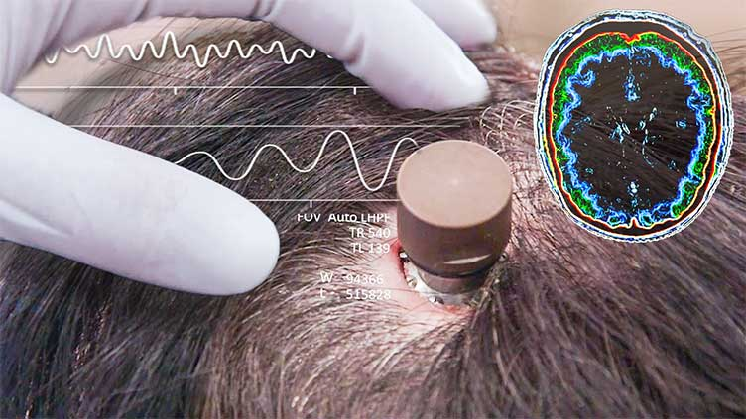
Seamless Computer and Mind Connection
Better the Brain Computer Interface
Zainab K Afridi
Temple university Tech Communication

Abstract
This proposal addresses the development of Brain-Computer Interfaces (BCIs) to improve the quality of life for individuals with severe neurological impairments. The primary problem is the current limitations in BCI technology, including issues with signal accuracy, durability, and adaptability to the brain's dynamic environment. The proposed solution focuses on enhancing BCI systems through advanced biosensors, specifically fiber photometry, which offers high sensitivity and minimal invasiveness.
Several candidates for biosensor solutions were evaluated, including two-photon microscopy, head-mounted microscopes, and fiber photometry. Criteria for selection included invasiveness, data accuracy, cost, and mobility. Fiber photometry emerged as the optimal choice due to its superior sensitivity, lower invasiveness, and cost-effectiveness.
Implementation involves addressing challenges such as improving signal-to-noise ratio, enhancing optical fiber design, precise genetic targeting, efficient data analysis, and navigating regulatory and ethical considerations. By overcoming these challenges, the proposed fiber photometry-based BCI system aims to provide reliable and high-quality neural data, facilitating better control of external devices.
The successful implementation of this technology has the potential to significantly enhance the independence and quality of life for patients, making BCIs a transformative tool in neurorehabilitation and beyond.

Keywords: Brain-Computer Interface (BCI), Neuralink, Fiber Photometry, Two-Photon Microscopy (2P), Head-Mounted Microscope, Neurotransmission, Calcium Imaging, Genetically Encoded Calcium Indicators (GECIs), Signal-to-Noise Ratio (SNR), Optical Fiber Design, Neural Activity Monitoring, Neuroprosthetic, Functional Magnetic Resonance Imaging (fMRI), Electrode Arrays, Neural Signals, Neurocircuit Activity, Fluorescent Biosensors, In Vivo Imaging, Neurotechnology, Biomedical Engineering, Machine Learning Algorithms, Data Analysis Pipelines, Closed-Loop Experiments, Neurorehabilitation.

Executive Summary
The proposed project seeks to tackle the critical challenge of advancing Brain-Computer Interfaces (BCIs) to significantly improve the quality of life for individuals with severe neurological impairments. Existing BCI technologies often struggle with limitations in signal accuracy, longevity, and adaptability to the brain's dynamic environment, which restrict their effectiveness and broad adoption. By developing more sophisticated BCIs, we aim to restore essential functions such as mobility and communication for patients, enhancing their independence and overall quality of life.
Crucial design requirements for this endeavor include achieving a high signal-to-noise ratio (SNR), ensuring minimal invasiveness, maximizing durability, and maintaining cost-effectiveness. Overcoming these challenges demands the development of flexible yet robust optical fibers, precise genetic targeting of neural indicators, and streamlined, efficient data analysis pipelines. Beyond these technical hurdles, the project must also address regulatory and ethical considerations, ensuring adherence to FDA standards and fostering public trust.
Our proposed solution centers on fiber photometry, a minimally invasive technique utilizing genetically encoded calcium indicators to monitor neural activity with remarkable sensitivity and specificity. This approach allows for real-time, accurate observation of brain signals. Innovations include advanced materials for optical fiber construction to enhance flexibility and longevity, coupled with innovative signal processing algorithms for superior data accuracy. This solution not only meets critical design constraints but also introduces groundbreaking advancements in optical fiber engineering and data analysis methods, solidifying its potential for transformative impact.
If successful, this project promises immediate business benefits, positioning partnering companies as a leader in BCI technology and unlocking new markets in neurorehabilitation and assistive devices. Broader implications span applications in neuroprosthetic, cognitive enhancement, and brain-machine interfaces for healthy individuals, fostering innovation across multiple fields. While challenges related to regulatory approval and ethical considerations remain, transparent and proactive engagement will address these obstacles, ensuring the project's success and societal acceptance.
Key stakeholders in this project include healthcare providers seeking effective rehabilitation solutions, government agencies and military organizations looking to support veterans and active-duty personnel who have sustained neurological injuries, and rehabilitation centers aiming to integrate cutting-edge BCIs into clinical practice. For example, military veterans who have suffered debilitating injuries in the line of duty could regain mobility and communication capabilities, empowering them to achieve greater independence and reintegration into society. Additionally, healthcare systems and insurers could benefit from reduced long-term care costs by enabling faster and more effective recovery for patients.

Table of Contents
Abstract 1
Executive Summary 2
Problem Analysis 4
Overview of the issue and its significance 4
STEM Fundamentals of the Problem 4
Prior Responses 6
Design Objectives and Constraints 6
Project Definition 7
Categories of Solutions Considered 7
2P Microscopy 9
Head-Mounted Microscopes 10
Fiber Photometry 12
Comparing Possible Solutions 13
Project Recommendation 14
Proposed Solution 14
Challenges in Design and Implementation 14
Anticipated Project Outcomes and Impacts 16
Work Cited 17

Figures
Figure 1 5
Figure 2 7
Figure 3 8
Figure 4 9
Figure 5 10
Figure 6 10
Figure 7 10
Figure 8 12

Tables
Table 1 14

Problem Analysis

Overview of the issue and its significance
Scientists and doctors have been working endlessly throughout time to deliver a solution to make the lives of patients who have tragically lost the ability to live a normal life easier. In order to achieve these goals, teams of various companies, such as Neurable, Neuralink, Precision, and more, have been working on developing Brain-Computer Interfaces (BCI). A BCI would let a patient’s “brain communicate with and control external software or hardware, like a computer or robotic limb,” (Built In, 2024) using neurotransmission wave reading threads/sensors that catch signals.
The Neuralink was a device designed by Elon Musk and his team. Launched in 2016, the Neuralink’s first human trail was held in January 2024 on patient Noland Arbaugh. Its main goal was to “create brain-computer interfaces: devices connected to the brain that allow people to communicate with computers by thought alone” (New Scientist). The disk is like a coin sized puck, which sits on top of the head. It has thin, hair sized wires that spread across the brain and collects signals from neurons. To implant this chip, open skull surgery is required, and this can come with its own set of risks. The brain is always changing in size as it swells and shrinks throughout the day; furthermore, the brain is not a stationary organ, it has unpredictable movements. Due to these facts, one of the major problems that arose during the first human trial was the threats retracting, giving the computer inaccurate readings. In order to fix this, it is required to reoperate on the recipient, which comes with a separate problem set such as infections. Additionally, the threads pierce the brain. With every reoperation, the brain gets damaged increasingly.
Looking into the individual parts that go into studying the brain to make a BCI, brain mapping techniques, particularly fMRI, contribute to understanding the functional networks involved in various cognitive tasks. Insights gained from fMRI studies inform BCI developers about which brain regions are most active during specific activities, guiding the design of more effective interfaces. By mapping the brain’s functional architecture, researchers can identify optimal sites for BCI electrode placement, enhancing signal clarity and responsiveness (Logothetis, 2008).

STEM Fundamentals of the Problem
Taking a deeper look at the threads, each one contains 16 electrodes that convert neural activity into computer commands, allowing actions like typing or cursor movement. Since there are 64 threads, there are 1024 electrodes distributed across is. However, reports indicate that approximately 870 of these electrodes in Arbaugh’s implant became non-functional, complicating the situation and prolonging repairs (WSJ). This issue took weeks to fix as the scientists avoided taking out the whole thing and putting it back (Popular Science, 2024).
Although the exact reasons for the thread detachment are unclear, it is believed that the brain’s natural movements may have contributed to this issue (Popular Science, 2024). This entails that we need to work on a design that can adapt to the changes and movement of the brain (WIRED, 2024).
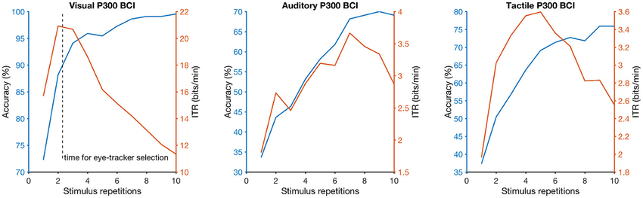
Along with the lack of adaptability most BCI devices have towards the ever-changing brain, BCI devices have a slow rate of signal transfer. The system must keep up with fast brain neurotransmission which has a speed of around 269 mph or 115,197 ft/sec (USCB ScienceLine, 2009). Maintaining signal accuracy and speed remains a significant hurdle, particularly in visual stimulus-based BCIs, where performance can vary widely based on stimulus repetition (PMC, 2021).
Figure 1: Performance metrics for three types of Brain-Computer Interfaces (BCIs) using the P300 signal.

Figure 1 shows three graphs, each representing the performance of diverse types of Brain-Computer Interface (BCI) systems: Visual P300 BCI, Auditory P300 BCI, and Tactile P300 BCI. Each graph has two lines:
- Blue Line: Shows the accuracy (%) of the BCI system as the number of stimulus repetitions increases.
- Orange Line: Represents the Information Transfer Rate (ITR) in bits per minute, which indicates how fast and efficiently the system can send information.
The number of stimulus repetitions affects both accuracy and the speed of information transfer (ITR), with faster systems potentially sacrificing accuracy and vice versa (Friedenberg et al., 2018).

Prior Responses
In light of the challenges faced by current BCI technologies, it is valuable to think about both historical and recent attempts to solve similar problems in the field of biomedical engineering and neurotechnology. For example, early neuroprosthetic devices, aimed to restore movement for paralyzed patients, faced significant challenges regarding biocompatibility, safety, and the complexity of neural signals. One lesson learned from these early devices is the importance of iterative design and testing. Many prototypes were met with initial failure due to inadequate integration with biological systems, underscoring the necessity for extensive preclinical studies and gradual human trials.
Taking the issues into account, many companies such as Precious Neuroscience have taken it upon themselves to make BCI “implants safer, smarter and reversible” (Tech Crunch, 2023). In order to achieve this, they work on making the electrode arrays or threads “ultra-thin,” so that it does not need to pierce the brain “yet can collect hundreds of times more data than traditional arrays.”
Despite advancements, the challenges faced in brain-wave detection and mapping also apply to BCI development. The complexity of interpreting neural signals remains a hurdle, as individual variability in brain function can lead to inconsistent performance across different users (Buzsáki et al., 2012). Moreover, ensuring safety and comfort in implantable devices, as well as addressing ethical considerations, is crucial for widespread acceptance and success in clinical settings.
Cost is another crucial factor to consider, and we can learn from older trials. The development of complex medical devices has often been hindered by high manufacturing costs, which can limit accessibility. For instance, the high price of certain prosthetic limbs has prompted initiatives to develop more affordable, 3D-printed alternatives. These efforts illustrate the potential for cost-effective solutions that do not compromise on quality, a principle that BCI developers could adopt to make their devices more widely accessible.

Design Objectives and Constraints
The primary focus of this proposal is to find the most optimal mechanics, materials, and methods to make the most efficient Brain Computer Interface. The solution will not only be cost efficient, but will also require the least maintenance, which will ensure the comfort of the patient as they will have to go through less surgeries – do it right at once so you do not have to do it again. A couple of classifications we will consider the invasiveness of the procedure, the surgery needed for imaging, how the data is collected, cost, and the mobility of the sensors.
The FDA requires rigorous testing to ensure that any device used on humans is safe and effective. This includes extensive preclinical studies and clinical trials to demonstrate that fiber photometry does not cause harm and accurately measures neuronal activity. Fiber photometry involves the implantation of optical fibers into the brain, which is considered an invasive procedure. The FDA has strict regulations regarding invasive medical devices, requiring detailed evidence of safety and minimal risk of complications such as infection or tissue damage. Furthermore, it is mandated that any device collecting and transmitting data must ensure the privacy and security of patient information (AMA J Ethics, 2021). This includes compliance with regulations such as the Health Insurance Portability and Accountability Act (HIPAA). The classification of fiber photometry devices under FDA regulations can affect the approval process. Devices classified as Class III (high risk) require more stringent testing and approval processes, such as PMA (premarket approvals). If fiber photometry devices are classified as high-risk, this could further complicate and extend the regulatory approval process (Kielbinski, 2024).

Project Definition

Categories of Solutions Considered
While Neuralink and other BCI technologies have advanced quite far, there is always room for improvement. In this section, we will be looking at feasible solutions to the raising problems we have been seeing in BCIs.
The first solution lays along the lines of finding better technology for the devices used to read brain waves and neurotransmitters. One example of pre-existing advances we could use is fluorescent biosensors (FB). They typically consist of a fluorescent protein or dye that changes its light emission properties upon binding to a target molecule, such as a neurotransmitter (Roth and Ding, 2020). These neurotransmissions can be imaged using portable devices such as 2P microscopy, miniaturized head-mounted microscopes, or fiber photometry.
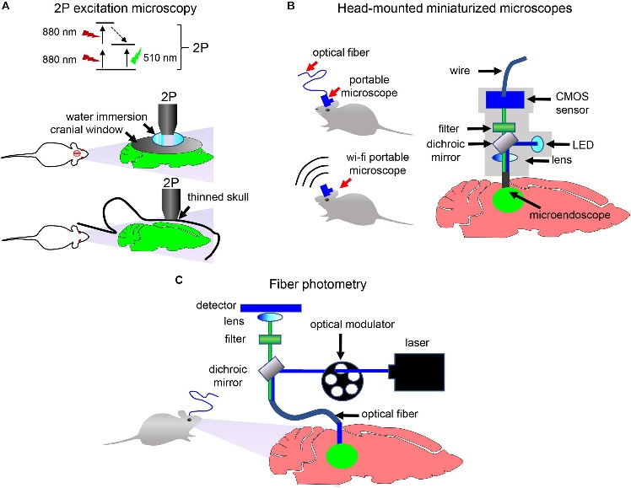
Figure 2 presents methods for detecting and imaging neuronal activity in vivo (live subjects). (A) shows two-photon (2P) excitation microscopy used for non-invasive brain imaging in immobilized animals. (B) displays a head-mounted portable microscope that captures neurotransmission in freely moving animals, with data transferred via optical fiber or wirelessly. (C) depicts a fiber photometry setup, where an implanted optical fiber enables detection of fluorescence signals, modulated by an optical modulator to measure neuronal activity in freely moving animals (Friedenberg et al., 2018).
Figure 2: Three distinct methods for monitoring neural activity in animal models.

The second category of solutions would be to improve neuro threads and electrodes for Brain-Computer Interfaces by exploring various advanced materials. Neuralink uses thin threads that are made by combining conductive metals with polyamide, a type of plastic (Hughes, 2024). Some alternate materials include carbon-based materials (graphene, carbon nanotubes, and pyrolyzed-photoresist films), or flexible metallic materials (gold and platinum). Selecting the most suitable material requires careful consideration of several factors. First, the material must be functional and safe for vivo use, ensuring that it does not degrade or cause harmful reactions within the brain. Additionally, biocompatibility and durability are essential, as the material must withstand the brain's dynamic environment over time without losing functionality or risking the patient's health. Finally, the chosen material must facilitate stable data collection, providing clear, consistent recordings and reliable stimulation to ensure precise neural communication. By meeting these criteria, we can develop electrodes that enhance both the safety and effectiveness of BCIs, ultimately contributing to more stable, high-performing interfaces for users.

While reengineering the material of the threads may be a probable and suitable solution, this project will focus on improving the overall system of BCI. In order to do this, we will be looking at alternate ways to screen, read, and image brain activities via biosensors. “Neurotransmitter biosensors allow precise spatiotemporal mapping of neurotransmission in the brain of animals” (Leopold, Shcherbakova, & Verkhusha, 2019). It is necessary to review the options of 2P microscopy, miniaturized head-mounted microscopes, or fiber photometry in terms of freely moving humans.

Figure 3: Web of Candidate Solutions

2P Microscopy
Two-photon (2P) microscopy is an advanced imaging technique ideal for deep-tissue imaging, offering unique advantages in brain-computer interface (BCI) research. Unlike conventional single-photon or confocal microscopy, 2P microscopy uses near-infrared (NIR) laser light to excite fluorescent molecules through simultaneous absorption of two low-energy photons. This enables fluorescence generation only at the focal point, minimizing out-of-focus light and allowing precise imaging at depths up to 500 µm in intact tissues or whole organisms.
A key advantage of 2P microscopy is its ability to image deeper into biological specimens with minimal invasiveness. NIR photons penetrate tissues more effectively and are less likely to cause photodamage or photobleaching, which are critical considerations for long-term live-cell imaging in BCI studies. Additionally, 2P systems are particularly suited for imaging fast and dynamic processes, such as calcium signaling in neurons, by capturing high-resolution images with reduced background noise (Dempster & Wokosin, 2002).
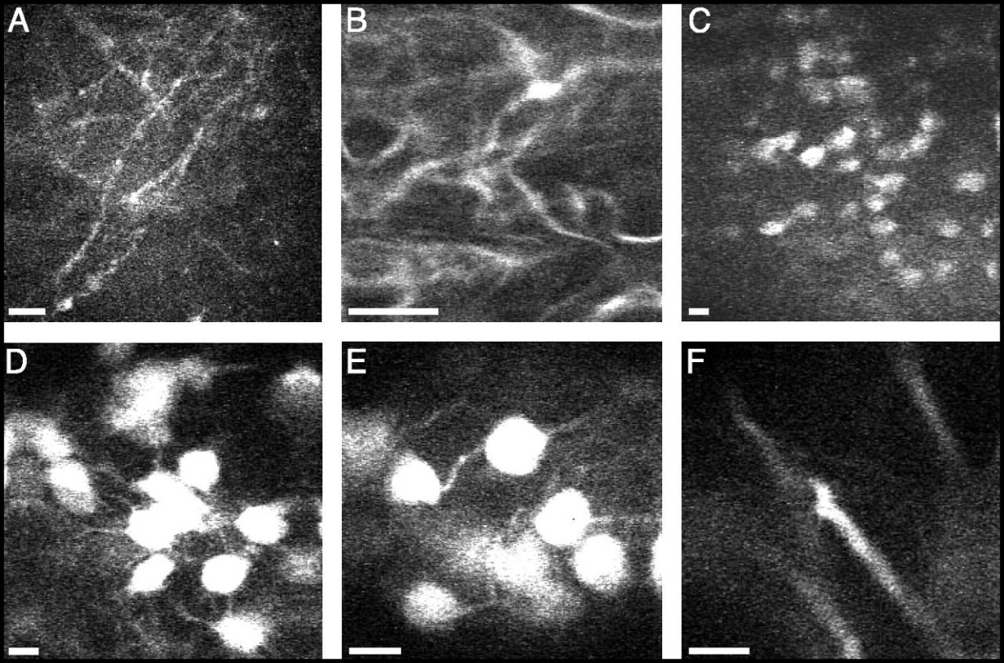
Figure 4: Neuro activities in living rats using 2P fluorescence.
Figure 4 show mammalian CA1 hippocampal neurons captured in living rats and mice using two-photon fluorescence micro endoscopy. This technique allows visualization of different cellular components:
- Image A: Di-I labeled dendrites in the s. oriens region of a live rat.
- Images B–F: Fluorescent cell bodies, basal dendrites, and apical dendrites in anesthetized YFP-H mice. These mice express YFP in some hippocampal pyramidal neurons.
Different endoscope probes were used, varying in diameter, numerical aperture (NA), and working distance (WD), with acquisition times ranging from 0.38 to 0.77 seconds. These parameters enabled detailed imaging of structures like pyramidal cell bodies (C, D, E) and dendrites (A, B, F) with high resolution (Jung et al., 2004).
Compared to other techniques like confocal microscopy, 2P systems can achieve superior contrast and sensitivity in thick samples while preserving sub-cellular detail. However, the systems are costly and complex, requiring specialized pulsed lasers and careful alignment. Furthermore, software limitations and hardware maintenance can pose challenges, emphasizing the need for robust integration of imaging systems with data analysis tools in BCI applications.
In BCI research, 2P microscopy is instrumental for observing neuronal activity and connectivity in real-time, aiding in the development of interfaces that rely on accurate monitoring of neural signals. Its ability to image deep into brain tissues without significant interference makes it an indispensable tool for advancing neuroscience and brain-machine technologies (Dempster & Wokosin, 2002).

Head-Mounted Microscopes
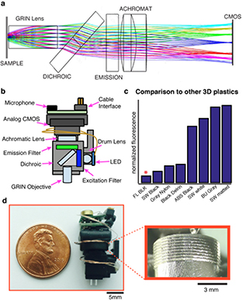
The mini-mScope is a lightweight, head-mounted miniature fluorescence microscope designed for imaging neural activity in freely behaving animals, such as mice and songbirds. It offers high-resolution imaging of cortical activity across large brain regions, making it a critical tool for studying behavior, learning, and neural connectivity over long timescales. The microscope enables calcium imaging, allowing researchers to monitor electrical activity at near-cellular resolution and create functional connectivity maps during complex behaviors. With the integration of See-Shells, transparent 3D-printed skulls, the system facilitates long-term studies spanning months or even years (Tremmel et al., 2022).
Figure 5
A custom-designed, 3D-printed, head-mounted fluorescence microscope (Tremmel et al., 2022):
A) Diagram of the optical emission pathway for the miniature microscope.
B) Microscope schematic showing a lightweight, robust body with a modifiable CAD design.
C) A comprehensive survey of 3D printers and materials identified Formlabs Black Resin as the optimal choice (marked with a red asterisk) due to its superior resolution and low autofluorescence—half that of black Delrin, a commonly used material in machined microscope designs.
D) Photograph of the microscope fabricated using a consumer-grade 3D printer (Form 2), with an inset highlighting the 3D-printed focusing threads featuring a 0.34 mm pitch.
Figure 6: Detailed depiction of a miniaturized. fluorescence imaging system
Figure 7

Key Features and Innovations (Tremmel et al., 2022):
- 3D-Printed Design: The microscope housing, built from consumer-grade 3D printing materials, ensures high precision, light blocking, and low autofluorescence. Using resins with high resolution, features like adjustable focal threads enhance functionality.
- Lightweight and Modular: Weighing less than 1.8 g, it uses GRIN lenses for short focal lengths and compatibility with a range of fluorophores. Configurable for wireless operation or active commutators, it can adapt to diverse experimental setups.
- Custom Software: Runs on macOS, using AVFoundation frameworks for synchronized audio-video acquisition. Data is saved in MPEG-4 format with real-time fluorescence analysis and CSV-based data logging for ROIs. Integration with Arduino microcontrollers enables low-latency control of LEDs and feedback stimuli.
- Near Real-Time Feedback: The system delivers feedback with an average latency of 23.9 ms ± 7.9 ms, supporting closed-loop experiments. Fluorescence signals or analog inputs (e.g., audio or electrophysiology) can trigger targeted feedback in experiments like brain-machine interfaces (BMI).
- Behavioral Context Integration: LED activation and data collection can be tied to specific behaviors, reducing photobleaching and streamlining analysis. For instance, the system detected bird vocalizations using Fourier transforms to trigger fluorescence imaging or feedback.
The mini-mScope integrates advanced imaging hardware, custom software, and real-time feedback capabilities to study neural circuit dynamics holistically. By enabling long-term, high-resolution imaging in freely behaving animals, it provides a versatile and cost-effective platform for neuroscience research, opening doors to understanding complex behaviors, brain connectivity, and neural adaptations over time.

Fiber Photometry
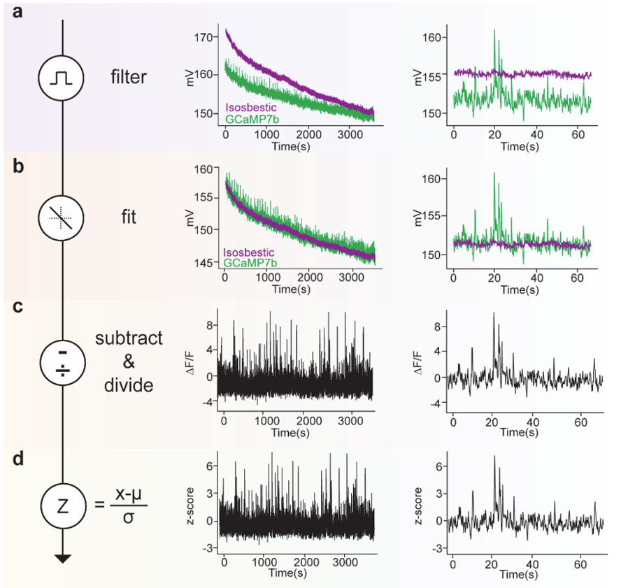
Figure 8: Data processing pipeline for analyzing calcium imaging.
Figure 8 demonstrates the process of extracting, fitting, and analyzing raw data for calcium imaging in dopamine axons within the dorsomedial striatum using the GCaMP7b indicator (Sherathiya et al. 2021). Two signals are recorded: an isosbestic signal (purple, 405nm excitation) and a calcium-dependent signal (green, 465nm excitation). This analysis is made using GuPPy (toolbox for the analysis of fiber photometry data).
(a) Filtering: The raw data is smoothed using a zero-phase moving average filter. The full trace over one hour and a one-minute segment are shown, highlighting the filtered data.
(b) Fitting: The isosbestic signal serves as a control, and a least-squares linear regression is applied to fit this control signal to the calcium-dependent signal, accounting for any baseline drift.
(c) Subtraction and Division: Using the fitted control, the change in fluorescence (ΔF/F) is calculated by subtracting the control signal from the calcium-dependent data and normalizing it. This step isolates the calcium-dependent activity from non-calcium-related fluorescence changes.
(d) Z-score Calculation: The data is standardized by calculating the z-score, which involves subtracting the mean and dividing by the standard deviation. This normalization allows comparison across different time points and experimental conditions.

Comparing Possible Solutions
Categories | 2P Microscopy | Head-Mounted Microscopes | Fiber Photometry
Surgery Needed for Imaging | Two types of accessing:  1. Skull window technique which thins the skull to around of ∼15 μm.  2. Removing a piece of the skull and replacing it with glass cranial window | Deep brain imagining with limited skull surgery (cranial window) | Requires implanting an optical fiber
Invasiveness | Moderately invasive. | Less invasive compared to 2P Microscopy. | Least invasive among the three
Connection to data reader | Wired | Wired or Wireless (both options available) | Wired or Wireless (both options available)
Data Reading | Calcium imaging | 1. Connected with a detection device using optical fiber  2. Has wireless options | Has high sensitivity detection capabilities
Mobility | Can only be used on stationary patients | Can be used on moving patients | Can be used on moving patients
Cost | $200,000 to over $1 million | $50,000 to $150,000 | $10,000 to $50,000
Table 1: Comparative assessment of candidate solutions.
Taking both the pros and the cons of each biosensor into consideration, it can be concluded that the best current option would be fiber photometry. Not only is it the most sensitive, which would allow for better data collection and readings, it is also remarkably similar in structure to current BCIs. To fully understand whether this is the ideal approach or not, we will need to further investigate the details of biosensors, which we will do in the next section.

Project Recommendation

Proposed Solution
The biosensors we propose are capable of recording neurotransmission activities many millimeters deep into the brain, but the pros of the fiber photometry standout. The straightforward nature of fiber photometry equipment and its high sensitivity in detecting neuronal activities make it highly appealing to researchers and scientists (Resendez and Stuber, 2015). It utilizes fluorescence-based measurements, offers a minimally invasive means to monitor neural activity. This method involves the use of genetically encoded calcium indicators, which are introduced into specific neurons or neural circuits. When these neurons become active, the calcium influx triggers fluorescence changes that can be measured in real-time. This technique enables researchers to study the brain’s activity patterns in awake and freely moving animals, a crucial aspect for understanding dynamic neural processes. This provides crucial insights into the synchronous activity patterns within specific neurocircuits during both normal and abnormal behavioral states. The lightweight and compact nature of these devices makes them versatile for use in various behavioral experiments, such as sensory tasks, and complex learning tasks in operant chambers.
“We find that the 80% of the effective signal arises from a 105-106 µm3 volume extending ~200 µm from the fiber face, and thus permitting a spatial interpretation of measurements made with fiber photometry” (Pisanello et al., 2018). This means that, in the fiber photometry setup, the majority (80%) of the recorded signal originates from a relatively small volume of brain tissue, measuring about 105–106 cubic micrometers ($μm^{3}$). This volume extends approximately 200 micrometers away from the tip of the optical fiber that is used to collect signals. This finding indicates that fiber photometry mainly detects signals from a localized area near the fiber tip, allowing researchers to interpret the data with some spatial specificity. Thus, measurements from fiber photometry reflect activity within a defined region of tissue near the fiber, rather than capturing signals from a much broader area, making it possible to infer spatial information about neural activity in this targeted zone.

Challenges in Design and Implementation
Implementing fiber photometry for neural activity monitoring comes with several engineering and practical challenges:
- Signal-to-Noise Ratio (SNR):
  - Causes and Complexities: Ensuring a high SNR is critical for reliable data interpretation. Factors such as background fluorescence, light scattering, and movement artifacts can degrade the signal quality.
  - Progress Toward Overcoming: Researchers can explore improved optical filtering techniques, advanced signal processing algorithms, and the development of brighter, more stable fluorophores to enhance SNR (Kim et al. 7).
- Optical Fiber Design:
  - Causes and Complexities: The optical fibers used must be lightweight and flexible to minimize discomfort and interference with the animal's natural behavior. However, this flexibility can make them prone to damage or wear over time.
  - Progress Toward Overcoming: Engineers could investigate the use of novel materials for optical fibers that combine durability with flexibility. Testing fibers under various conditions and incorporating protective coatings may also be beneficial (Simone et al.).
- Genetic Targeting:
  - Causes and Complexities: Introducing genetically encoded calcium indicators requires precise targeting to ensure that only the desired cell populations are labeled. Off-target expression can lead to misleading results.
  - Progress Toward Overcoming: Advances in viral vector design and promoter specificity could reduce off-target effects. Collaborative studies with molecular biologists to refine targeting methods may also provide solutions (Simone et al.).
- Data Analysis and Interpretation:
  - Causes and Complexities: The large volume of data generated by fiber photometry experiments necessitates efficient analysis pipelines. Distinguishing meaningful signals from noise and artifacts adds to the complexity.
  - Progress Toward Overcoming: Developing machine learning algorithms tailored to fiber photometry data could automate and improve the accuracy of analysis. Open-source tools and community-shared datasets might accelerate progress in this area (Bridge et al, 2024).
- Regulatory and Ethical Considerations:
  - Causes and Complexities: For clinical applications, obtaining FDA approval and addressing ethical concerns about genetic manipulation are significant hurdles.
  - Progress Toward Overcoming: Collaborations with regulatory experts and bioethicists could streamline the approval process. Public outreach to communicate the safety and benefits of this technology might also alleviate ethical concerns (Simone et al.).

Anticipated Project Outcomes and Impacts
Brain-Computer Interfaces (BCIs) hold the potential to revolutionize the lives of individuals who have lost the ability to perform everyday tasks due to neurological conditions or injuries. By enabling direct communication between the brain and external devices, BCIs can restore functions such as movement, communication, and control over the environment, significantly enhancing the quality of life for patients.
For instance, individuals with paralysis could regain the ability to move prosthetic limbs or control computers and other devices through thought alone. This level of independence can dramatically improve their daily lives, providing them with new opportunities for interaction and engagement with the world around them.
However, the transformative potential of BCIs underscores the importance of addressing the design and implementation challenges meticulously. Ensuring high signal quality, durable and flexible optical fibers, precise genetic targeting, efficient data analysis, and compliance with regulatory and ethical standards are all critical to the successful deployment of BCIs.
By overcoming these challenges, we can develop BCIs that are not only effective but also safe and accessible. This will pave the way for widespread adoption and integration of BCIs into clinical practice, ultimately making a profound difference in the lives of countless individuals.
The benefits of this technology extend beyond medical applications. For example, BCIs could play a crucial role for the military, aiding veterans and service members injured in the line of duty. By restoring motor function or communication abilities, BCIs can empower out-of-commission officers to regain independence and re-engage in meaningful aspects of their personal and professional lives. Additionally, stakeholders such as healthcare providers, rehabilitation centers, and government agencies stand to benefit from improved patient outcomes and reduced long-term care burdens.
The journey to perfecting BCIs is complex, but the impact on human lives makes it a worthy endeavor. Proper implementation is crucial to unlocking the full potential of this groundbreaking technology, ensuring that it can truly change lives for the better while providing solutions that address the needs of stakeholders across multiple sectors.

Work Cited

- Becher, Brooke. “Brain-Computer Interfaces (BCI), Explained.” Built In, 24 July 2024, https://builtin.com/hardware/brain-computer-interface-bci. Accessed 24 Sept. 2024.

- “Brain-Computer Interfaces and the Future of Bioelectronics.” CAS Insights, 2024, https://www.cas.org/resources/cas-insights/brain-computer-interfaces-and-the-future-of-bioelectronics.

- Bridge, Matthew F., et al. "FiPhA: an open-source platform for fiber photometry analysis." Neurophotonics, vol. 11, no. 1, 2024, article 014305, doi:10.1117/1.NPh.11.1.014305.

- Buzsáki, G., Anastassiou, C. A., & Koch, C. “The Origin of Extracellular Fields and Currents: EEG, ECoG, LFP and Spikes.” Nature Reviews Neuroscience, vol. 13, no. 6, 2012, pp. 407-420.

- Chappell, Bill. “Elon Musk’s Neuralink Implant Is Ready for Human Testing.” NPR, 30 Jan. 2024, https://www.npr.org/2024/01/30/1227850900/elon-musk-neuralink-implant-clinical-trial. Accessed 24 Sept. 2024.

- Dempster, John, and David Wokosin. "Fluorescence Imaging Systems: A Quick Overview of the Technology." Physiology News Magazine, Autumn 2002, The Physiological Society, www.physoc.org/magazine-articles/fluorescence-imaging-systems-a-quick-overview-of-the-technology/.

- “How Does a Brain–Computer Interface Work?” Scienceline, University of California, Santa Barbara, 2019, http://scienceline.ucsb.edu/getkey.php?key=1950. Accessed 24 Sept. 2024.

- Hao, Karen. “Everything We Know About Neuralink’s Brain Implant Trial.” Wired, 19 Sept. 2023, https://www.wired.com/story/everything-we-know-about-neuralinks-brain-implant-trial/. Accessed 24 Sept. 2024.

- Hao, Karen. “Neuralink’s Brain Implant Has Problems.” Wired, 20 July 2023, https://www.wired.com/story/neuralinks-brain-implant-issues/. Accessed 24 Sept. 2024.
- Hao, Karen. “Neuralink’s First Patient Shares His Experience with Elon Musk’s Brain Implant.” Wired, 21 Sept. 2023, https://www.wired.com/story/neuralink-first-patient-interview-noland-arbaugh-elon-musk/. Accessed 24 Sept. 2024.

- Jennings, Scott G., and Garret D. Stuber. "In Vivo Calcium Imaging to Illuminate Neurocircuit Activity Dynamics Underlying Naturalistic Behavior." Neuropsychopharmacology, vol. 40, 2015, pp. 238-256, https://www.nature.com/articles/npp2014206.

- Jung, Juergen C., et al. "In Vivo Mammalian Brain Imaging Using One- and Two-Photon Fluorescence Microendoscopy." Journal of Neurophysiology, vol. 92, no. 5, 2004, pp. 3121-3133. American Physiological Society, doi:10.1152/jn.00234.2004.

- Kim, Christina K., et al. "Simultaneous fast measurement of circuit dynamics at multiple sites across the mammalian brain." Nature Methods, vol. 13, no. 4, 2016, pp. 325-328. Stanford University, https://web.stanford.edu/group/dlab/media/papers/kimNMeth2016.pdf.

- Leopold, Anna V., Daria M. Shcherbakova, and Vladislav V. Verkhusha. "Fluorescent Biosensors for Neurotransmission and Neuromodulation: Engineering and Applications." Frontiers in Cellular Neuroscience, vol. 13, 2019, https://www.frontiersin.org/articles/10.3389/fncel.2019.00474/full.

- Logothetis, N. K. “What We Can Do and What We Cannot Do with fMRI.” Nature, vol. 453, no. 7197, 2008, pp. 869-878.

- Lomas, Natasha. “Precision Neuroscience Aims to Make Brain Implants Smarter and Reversible.” TechCrunch, 31 Jan. 2023, https://techcrunch.com/2023/01/31/precision-neuroscience-is-making-brain-implants-safer-smarter-and-reversible/. Accessed 24 Sept. 2024.

- “Modern Fluorescent Biosensors for Neurotransmitters and Neuromodulators.” Journal Name, vol. 10, no. 5, 2024, PubMed, https://pubmed.ncbi.nlm.nih.gov/31708747/#:~:text=Modern%20fluorescent%20biosensors%20for%20neurotransmitters%20and%20neuromodulators%20allow,vivo%20with%20millisecond%20precision%20and%20single%20cell%20resolution.

- “Neuralink Faces New Challenges with Implant Problems.” CNN, 9 May 2024, www.cnn.com/2024/05/09/tech/neuralink-implant-problem/index.html.

- Pisanello, Marco, et al. "Analytical and Empirical Measurement of Fiber Photometry Signal Volume in Brain Tissue." arXiv, 2018.

- Rodriguez, Vittoria Elliott. “Neuralink’s Brain Implant Wire Detachment Issues.” Popular Science, 5 Sept. 2023, https://www.popsci.com/health/neuralink-wire-detachment/. Accessed 24 Sept. 2024.

- Rynes, Mathew L., and Daniel Surinach. "Head-Mounted Microscope Captures Brain Activity in Freely Behaving Mice." Phys.org, 12 Apr. 2021, www.phys.org/news/2021-04-head-mounted-microscope-captures-brain-freely.html.

- Schießl, Ina Maria, and Hayo Castrop. "Deep Insights: Intravital Imaging with Two-Photon Microscopy." Pflügers Archiv - European Journal of Physiology, vol. 468, 2016, pp. 1505-1516. Springer, doi:10.1007/s00424-016-1832-7.

- Sherathiya, V.N., Schaid, M.D., Seiler, J.L. et al. GuPPy, a Python toolbox for the analysis of fiber photometry data. Sci Rep 11, 24212 (2021). https://doi.org/10.1038/s41598-021-03626-9

- Simone, Kathryn, et al. "Open-source, cost-effective system for low-light in vivo fiber photometry." Neurophotonics, vol. 5, no. 2, 2018, article 025006, doi:10.1117/1.NPh.5.2.025006.

- Somashekar, Bhanu Priya, and Upinder Singh Bhalla. "Discriminating Neural Ensemble Patterns Through Dendritic Computations in Randomly Connected Feedforward Networks." eLife, 2024, https://elifesciences.org/reviewed-preprints/95802.

- “Who, If Not FDA, Should Regulate Implantable Brain-Computer Interface Devices?" AMA Journal of Ethics, American Medical Association, Sept. 2021, https://journalofethics.ama-assn.org/article/who-if-not-fda-should-regulate-implantable-brain-computer-interface-devices/2021-09.

- Tong, Siu-Yin. “Next-Generation Brain–Computer Interfaces.” Sensors, vol. 21, no. 21, 2021, pp. 5746. PubMed Central, https://www.ncbi.nlm.nih.gov/pmc/articles/PMC8433803/. Accessed 24 Sept. 2024.

- Tremmel, Christoph, et al. "A Meta-Learning BCI for Estimating Decision Confidence." Journal of Neural Engineering, vol. 19, no. 4, 2022, IOP Publishing, doi:10.1088/1741-2552/aa6806.

- Yin, Pengfei, et al. "Advanced Metallic and Polymeric Coatings for Neural Interfacing: Structures, Properties and Tissue Responses." Polymers, vol. 13, no. 16, 2021, https://www.mdpi.com/2073-4360/13/16/2834.

